Climate
Objective 3a: Explain differences between weather and climate and the methods used to investigate evidence for changes in climate

Climate describes the long-term weather patterns of an area. These patterns include much more than average weather conditions. Climate also describes annual variations of temperature, precipitation, wind and other weather variables over time. For example, climate data could show the warmest and coldest temperatures recorded for a location.

Some years might be warmer, cooler, wetter, or drier than others, but during the average human lifetime, climates do not appear to change significantly. However, a study of Earth’s history over hundreds of thousands of years shows that climates have always been, and currently are, in a constant state of change. Scientists use different methods to study climate than they use to study weather.

Ice Core Samples
Throughout each year, layers of snow fall over the ice sheets in Greenland and Antarctica. Each layer of snow is different in chemistry and texture. Summer brings 24 hours of sunlight to the Polar Regions, and the top layer of the snow changes in texture: not melting exactly, but changing enough to be different from the snow it covers. The season turns cold and dark again, and more snow falls, forming the next layers of snow. Each layer gives scientists a treasure trove of information about the climate each year. Like marine sediments, an ice core provides a vertical timeline of past climates stored in ice sheets and mountain glaciers.

The ice sheets contain a record of hundreds of thousands of years of past climate, trapped in the ancient snow. Scientists recover this climate history by drilling cores in the ice and analyzing the air trapped within the layers. The type and amount of trapped particles, such as dust, volcanic ash, smoke, or pollen, tell scientists about the climate and environmental conditions when the snow formed. Air bubbles get trapped between the layers as the ice is formed, these bubbles tell scientists what gases were in the atmosphere and what the climate was like at the time the bubble was trapped.
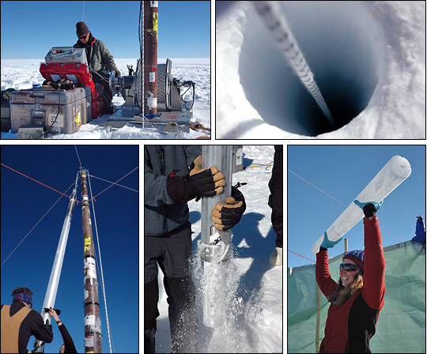

Tree Rings –
Each year trees add growth rings, which can indicate what sort of growing season the tree experienced. Dendrochronology is the study of climate change as recorded by tree growth rings. Each year, trees add a layer of growth between the older wood and the bark. This layer, or ring as seen in cross section, can be wide, recording a wet season, or narrow, recording a dry growing season. Because the rings are basically recording a good growing season or a bad growing season, they are indirectly recording more than just moisture. They also document temperature and cloud cover as they impact tree growth as well. This record of annual summer information is very important when you consider that certain types of trees grow slowly over hundreds and hundreds of years, and therefore contain a record of as many years of climate and climate change.

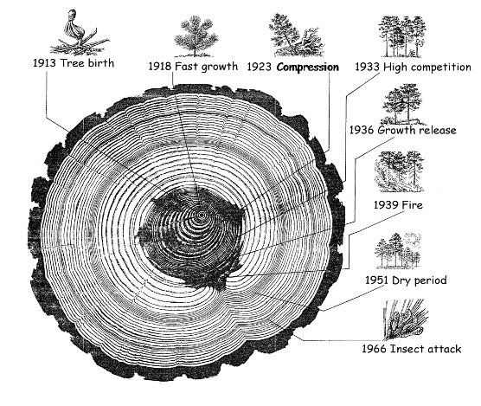

Global Temperatures
Global average temperature is one of the most-cited indicators of global climate change, and shows an increase of approximately 1.4°F since the early 20thCentury. The global surface temperature is based on air temperature data over land and sea-surface temperatures observed from ships, buoys and satellites. There is a clear long-term global warming trend, while each individual year does not always show a temperature increase relative to the previous year, and some years show greater changes than others. These year-to-year fluctuations in temperature are due to natural processes, such as the effects of El Ninos, La Ninas, and the eruption of large volcanoes. Notably, the 20 warmest years have all occurred since 1981, and the 10 warmest have all occurred in the past 12 years.
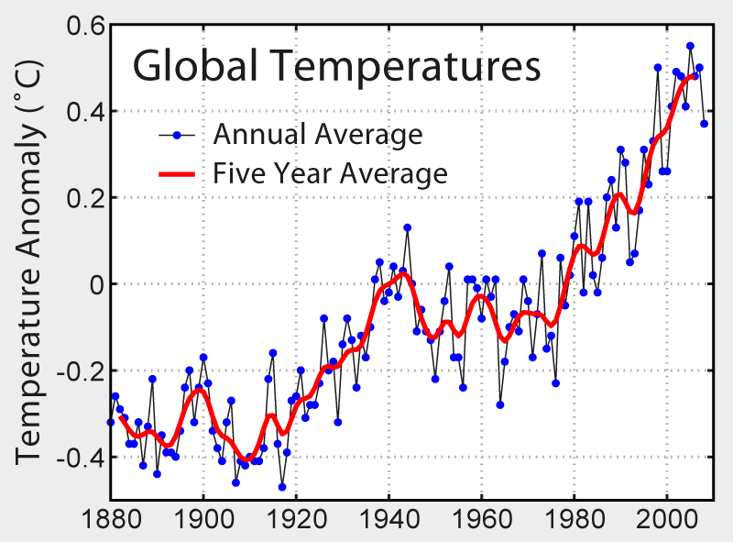

High Mountain Glaciers
A glacier is a body of snow and ice that moves. Glacier movement is detected by the presence of crevasses, cracks that form in the ice as the glacier moves. Glaciers are dynamic – changing in response to temperature and precipitation. A glacier forms when winter snowfall exceeds summer melting. It retreats when melting outpaces accumulation of new snow. Glaciers, by their dynamic nature, respond to climate variation and reveal the big picture of climate change. Unable to adapt, like living creatures, GNP’s (Glacier National Park) relatively small alpine glaciers are good indicators of climate, the long-term average of daily weather conditions. While occasional big winters or frigid weeks may occur, the glaciers of GNP, like most worldwide, are melting as long term mean temperatures increase. Glaciers are like a visual checking account of the status of the cold part of the ecosystem.
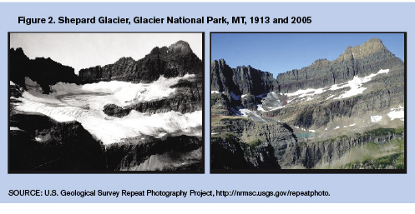
Artic Sea Ice
Sea ice forms and melts in sea water (oceans), as opposed to land based ice like glaciers. Sea ice begins to form when water temperature dips just below freezing. It grows into small sheets that look like pancakes, which can merge together to form large ice floes that span miles. As the ice forms, it expels the salt, which increases the density of the surrounding water and thus plays a role in global ocean circulation. Sea ice is moderated by sunlight, it grows in the winter and melts in the summer.

The primary role that sea ice plays in global climate is its ability to reflect the sun’s radiation. This property is called “albedo effect,” which is the measure of the reflecting power of a surface. The albedo of snow-covered sea ice is 0.90, meaning it reflects 90% of the sun’s radiation. The ocean surface, however, only reflects 10% of the sun’s radiation. Less sea ice and more ocean surface will lead to a warmer Arctic, and a warmer climate.
Satellite data shows that since the late 1970s, September Arctic sea ice extent has decreased by about 12% per decade. What's especially alarming is the decrease in multi-year ice. Sea ice is classified by age, usually as "new ice" or "multi-year" ice (meaning it survived many summer melting seasons). While new ice is very shallow, multi-year ice can grow to be quite thick, typically between 6 and 12 feet, and is very stable. In 1987, 57% of the observed ice pack was at least 5 years old, and around 25% of it was at least 9 years old. When they surveyed the Arctic again in 2007, only 7% of the ice pack was at least 5 years old, and the ice that was at least 9 years old had all but vanished. Likewise, sea ice thickness and volume have decreased markedly since the beginning of the satellite era.
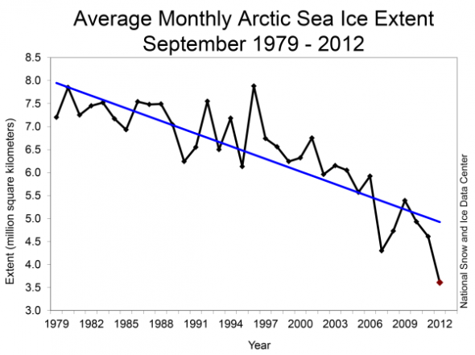
Questions:
1. How is climate different from weather?

2. What do the scientists look at in the ice core samples? What can they learn about climate change?

3. What do tree rings show us about the climate?

4. According to global temperature changes, what is happening to our climate?

5. How are glaciers and sea ice recorders of climate change? What do they show us?

